NOVEMBER 27, 2016

Danny Lyon – Message To The Future

BY MIKE MILLER
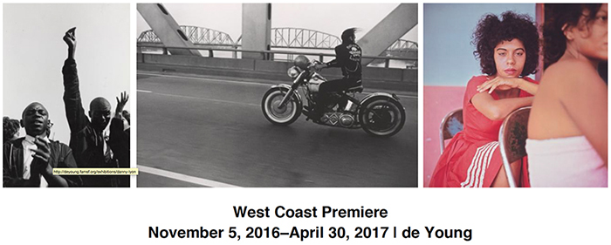
I met Danny Lyon in 1963 in Ruleville, Mississippi. I was on the staff of the Student Nonviolent Coordinating Committee (SNCC) visiting the Delta town in Sunflower County(home of Sen. James O. Eastland, one of the most notorious racists of the period) with Bob Moses, SNCC’s Mississippi Project Director and Martha Prescod, a young African-American University of Michigan student volunteer who was there for the summer. Danny took a picture of us talking with a local woman sitting on her porch. The picture became well-known because it was used on the cover of a widely distributed SNCC flyer. The story it told was that we were trying to convince the woman to register to vote. But Martha recently reminded me that we were asking directions!
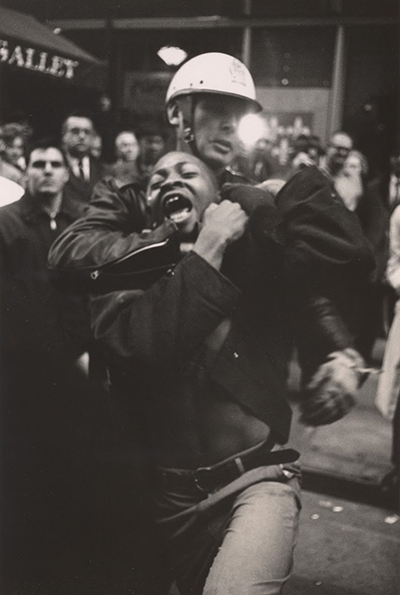
Danny Lyon, “Arrest of Taylor Washington, Atlanta,” 1963. Gelatin silver print, Image: 24 x 16 cm (9 7/16 x 6 1/4 in.); sheet: 25.4 x 20.3 cm (12 11/16 x 8 in.). Collection of the artist, L64 © Danny Lyon, courtesy Edwynn Houk Gallery, New York
From those beginning photographer days, Lyon went on to become one of the major photographers of the civil rights movement, and then on to 50 years of using photography to tell the stories of the marginalized, discriminated against and left-out, as well as other important subjects. Along the way, he branched out to make 16mm documentaries and videos. All these are now on display at San Francisco’s De Young Museum, having come here from the new Whitney in New York’s West Village. (Unfortunately, these are its only two stops.)
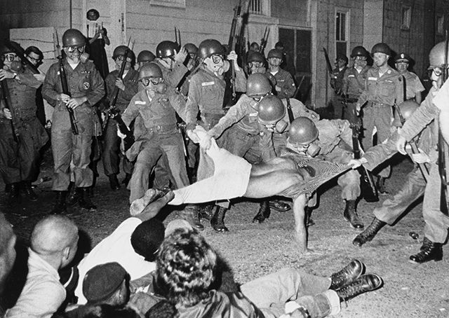
Danny Lyon, “Clifford Vaughs, another SNCC photographer, is arrested by the National Guard, Cambridge, Maryland,” 1964. Gelatin silver print. 20.32 x 25.4 cm (8 x 10 in.). Collection of the Corcoran/National Gallery of Art, CGA1994.3.3 © Danny Lyon, courtesy Edwynn Houk Gallery, New York
Of his civil rights movement photos, Julian Bond said, “They put faces on the movement, put courage in the fearful, shone light on darkness, and helped to make the movement move.” Lyons was one of a number of photographers assembled by SNCC Executive Director Jim Forman to be chroniclers of The Movement (we always capitalized the letters “T” and “M”); he and Matt Heron are the best known of them.
Among his subjects after the civil rights movement: biker subculture, Texas Department of Corrections prisoners, the destruction of Lower Manhattan to make way for the World Trade Center, his friend noted sculptor Mark di Suvero, New York City subway riders, Uptown Chicago Appalachians, the tattoo artistry of Bill Sanders, undocumented workers in the southwest, “Occupy” in Oakland and Los Angeles, workers in a Chinese coal producing area, Bolivian campesinos, street boys in urban Colombia and revolution in Haiti.
One of my favorites is of the yet-unknown sculptor Mark Di Suvero’s Fulton Fish Market loft. I was there with Mark’s younger brother Henry, a co-conspirator in the early days of the UC Berkeley student movement (1956/58). At the time, Mark was poor as a church mouse. It showed. The huge loft (a whole floor of what had once been a warehouse), where Mark both lived and worked, was barren except for his working tools and sculpting materials. At its center a bed was atop four hefty beams. Under the bed was a pot-belly stove, the only heating in the place. “Dear Mark” is one of the films. Less than five minutes, you can see it on YouTube.
Most of the photos are black-and-white. Many capture individual faces in moods ranging from joy and pleasure to trials and tribulations. The continuously screened six films range from five minutes to more than an hour. My favorite was tattooist Bill Sanders at work in his artistry, and philosophizing with his clients and with Lyon. He’s an alcoholic, and he’s consuming during the filming. Sometimes he can barely speak. When he does, he has surprising things to say: he’s against the war in Vietnam; he’s not a bigot.
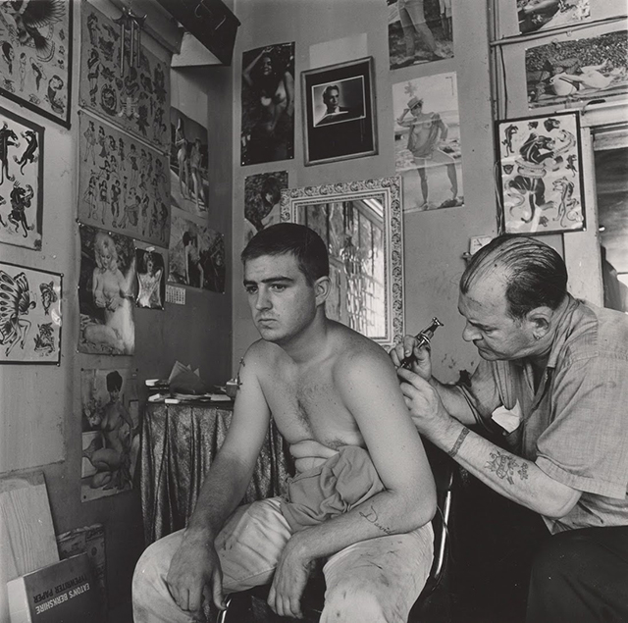
Danny Lyon, “Bill Sanders, Tattoo Artist, Houston, Texas,” 1968. Gelatin silver print, Image: 20.7 x 20.7 cm (8 3/16 x 8 3/16 in.); sheet: 35.6 x 27.9 cm (14 x 11 in.). Collection of the artist, L170 © Danny Lyon, courtesy Edwynn Houk Gallery, New York
Many of the pictures are of people in distressed situations. But these are not photos of despair. The vitality and durability of the human spirit shines through them, as does Lyons’ compassion and empathy.
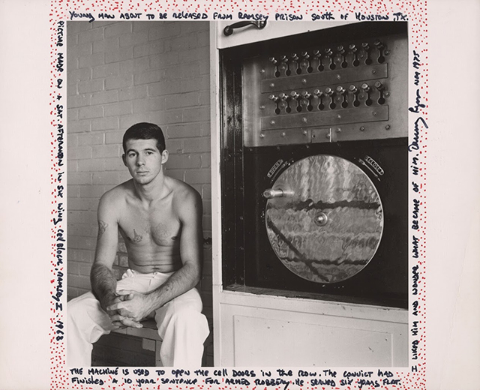
Danny Lyon, “Young Man About to Be Released from Ramsey Unit, Texas,” 1968/1975. Gelatin silver print (decorated). Image: 18 x 17.8 cm (7 1/16 x 7 in.); sheet: 20.3 x 25.4 cm (8 x 10 in.). Collection of the artist © Danny Lyon, courtesy Edwynn Houk Gallery, New York
One wish. The photos from Lower Manhattan show the skeletons of buildings. While you can infer from their destruction that a community was destroyed, I would like to have seen the faces of the displaced in at least some of the shots.
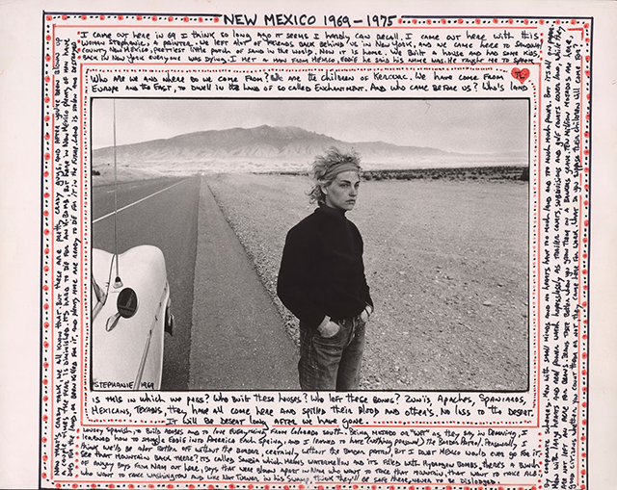
Danny Lyon, “Stephanie, Sandoval County, New Mexico,” 1969/1975. Gelatin silver print (decorated), Image: 16.7 x 25 cm (6 9/16 x 9 3/4 in.); sheet: 27.9 x 35.6 cm (11 x 14 in.). Collection of the artist, L108 © Danny Lyon, courtesy Edwynn Houk Gallery, New York
Lyon does more than take photos. He makes friends with his subjects, in some cases lifetime friends. He writes, “You put a camera in my hand, I want to get close to people. Not just physically close, but emotionally close, all of it.” He succeeds. Stupendously! See this show if you can, and leave yourself enough time not only to wander through the galleries but to watch the couple of hours of films and videos.
•••
Danny Lyon: Message to the Future is at the San Francisco De Young Museum, November 5, 2016 – April 30, 2017. Adults $22, seniors 65+ $17, students with current ID $13, youth 6-17, $7, members and children 5 and under free.

